Chassis No. | Engine No. | Consignee Name | Invoice No | LR No | LR Date | Trailer No | Delivery Location | Vehicle Type
994454 | 2453751 | Chandra And Company | KA2612000518 | 35203233 | 26-Aug-25 | CG07BT1978 | Singrauli, Madhya Pradesh | 40ft SLBT

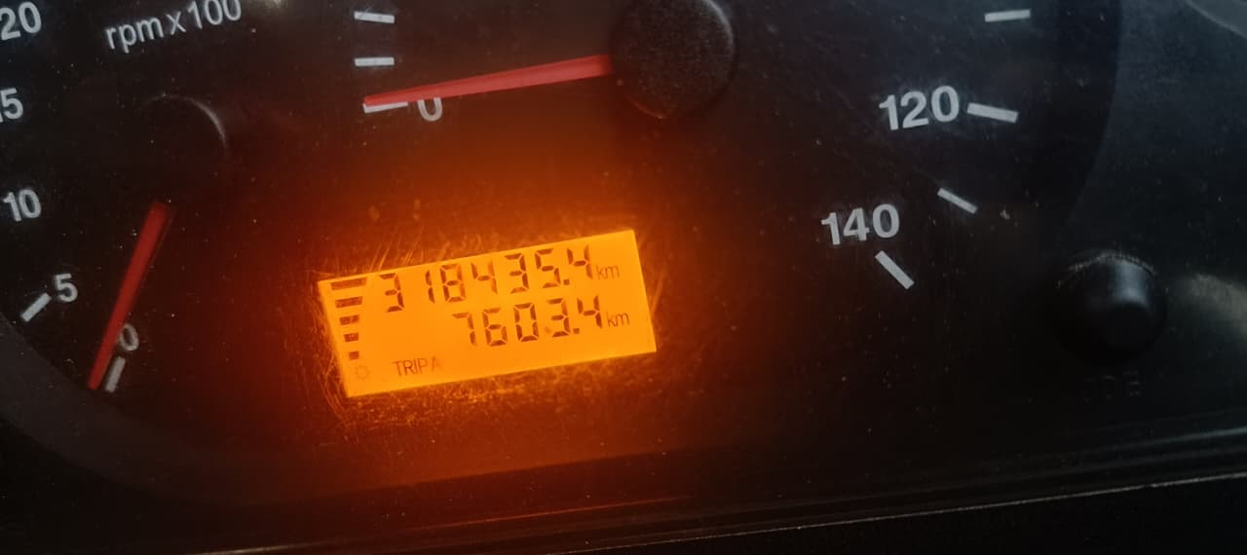

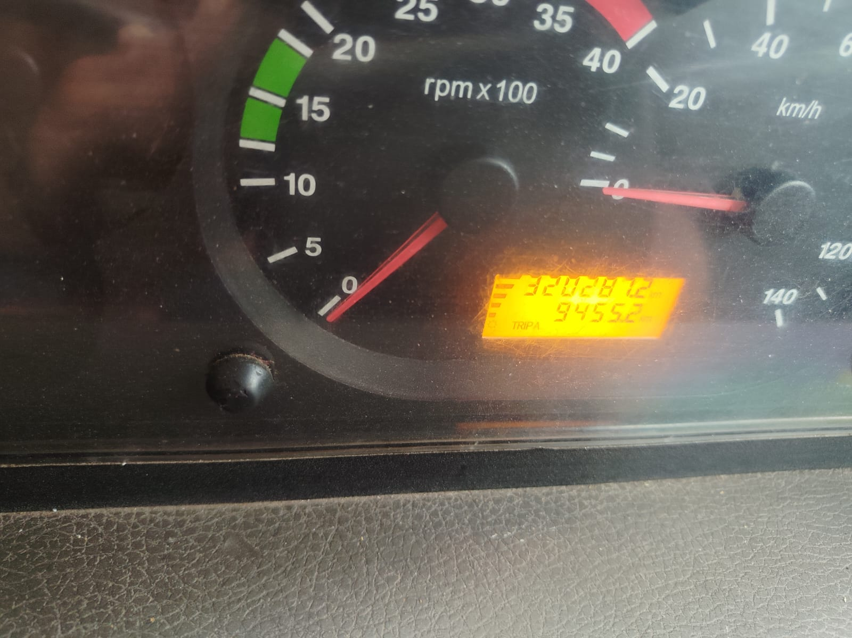

Chassis No. | Engine No. | Consignee Name | Invoice No | LR No | LR Date | Trailer No | Delivery Location | Vehicle Type
994526 | 2455764 | Chandra And Company | KA2612000519 | 35203234 | 26-Aug-25 | HR58B9217 | Singrauli, Madhya Pradesh | 40ft SLBT

